

**BIG DATA TECHNOLOGIES - LAB**

|  |  |  |
| --- | --- | --- |
| **NAME:** J. PRASHANTH | **R.NO:** 22R21A67F5 | **BRANCH/SEC:** CSD – C |
| **WEEK:** 07 | **TOPIC:** HIVE Commands. | **DATE:** 29th Oct, 2024 |

1. **PROBLEM STATEMENT:** Implement basic HIVE Commands.

**PROGRAM:**

* **Execute Hive Commands**:

CREATE DATABASE prash_db;

USE prash_db;

CREATE TABLE student_data (id INT, name STRING);

SHOW TABLES;

SELECT * FROM student_data;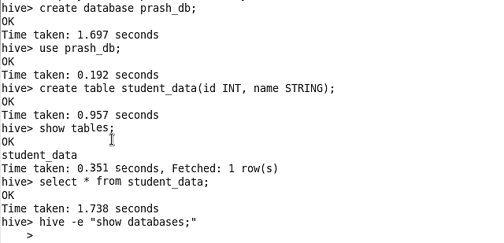

1. **Creating a Table Stored as an ORC File**

CREATE TABLE orc_tab (id INT, name STRING, salary FLOAT) STORED AS ORC;

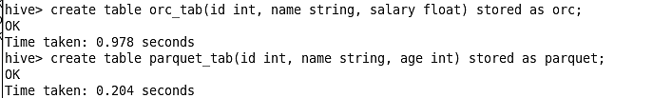

1. **Creating a Table Stored as a Parquet File**

CREATE TABLE parquet_tab (id INT, name STRING, age INT) STORED AS PARQUET;



1. **Loading Data into Tables**

* **Load Data into the Table from the HDFS Path**

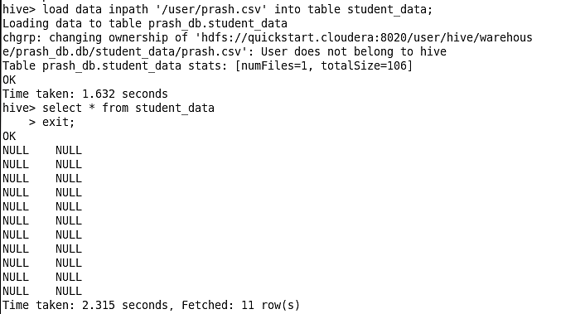



* **Insert Data Using Values**

**Parquet Table**

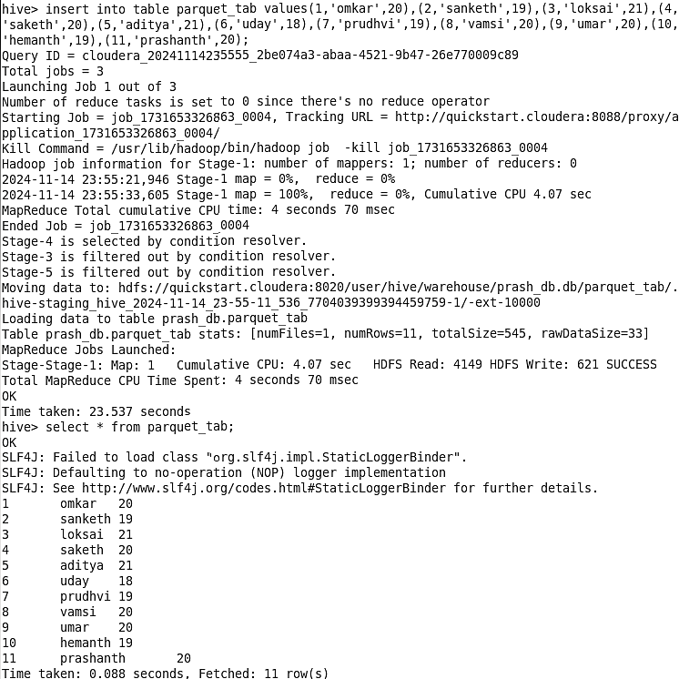

**Orc table**

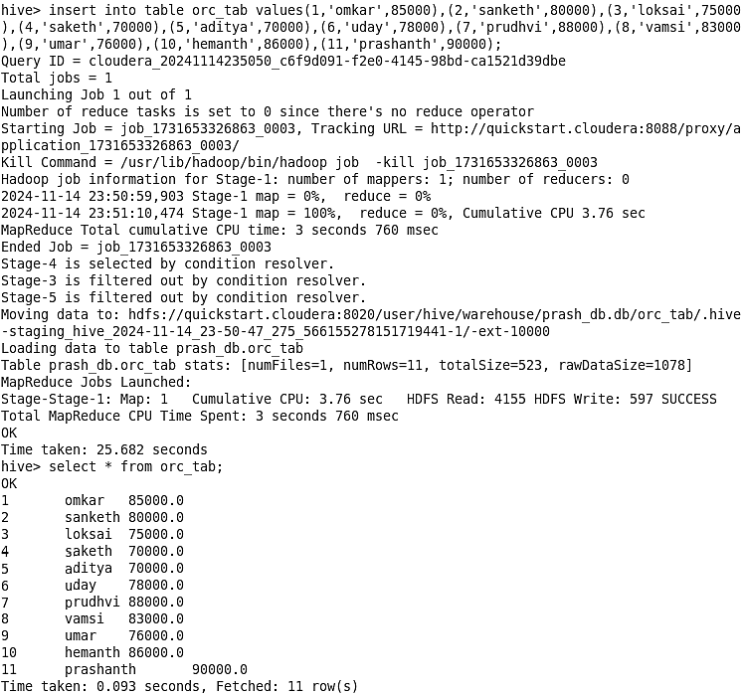



1. **Filtering Data**

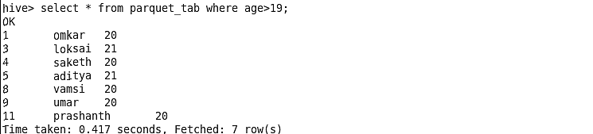

1. **Aggregate Functions (COUNT, GROUP BY, HAVING)**

**Salary count**

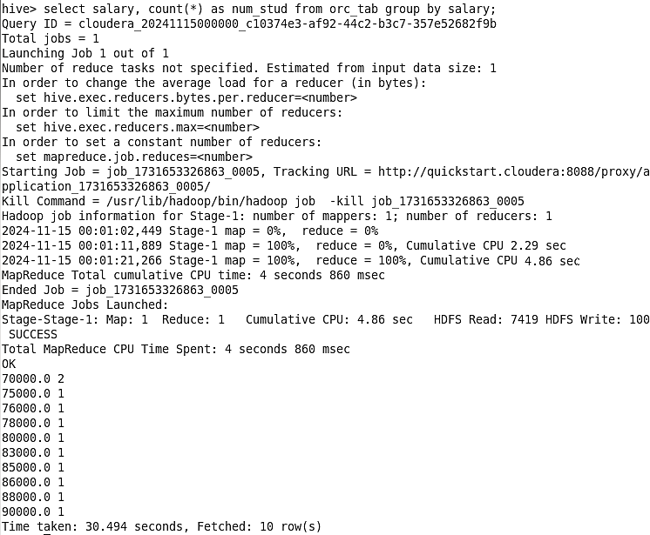



**Age count**

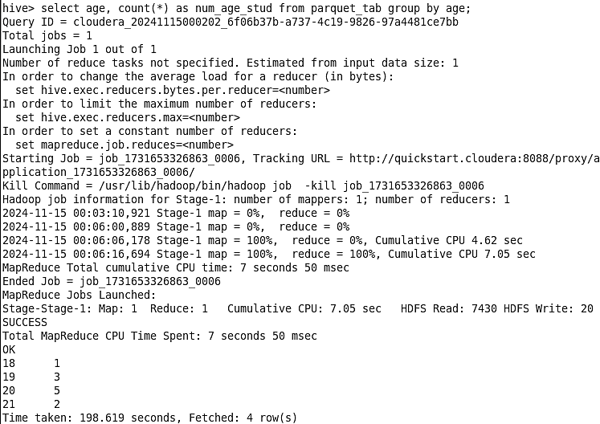



**Having average salary > 75,000**

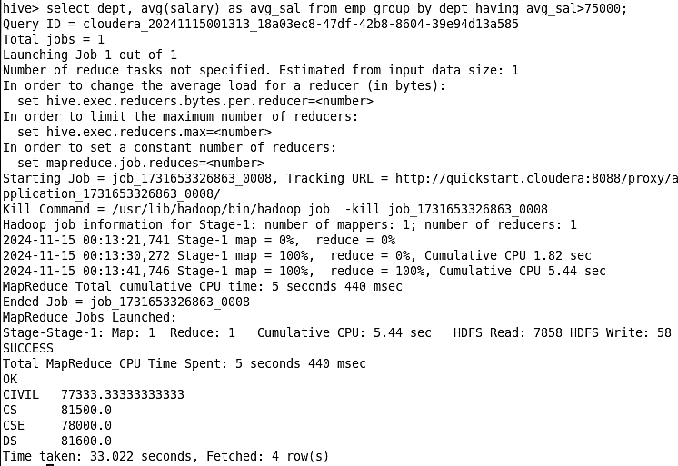

1. **Inner Join**

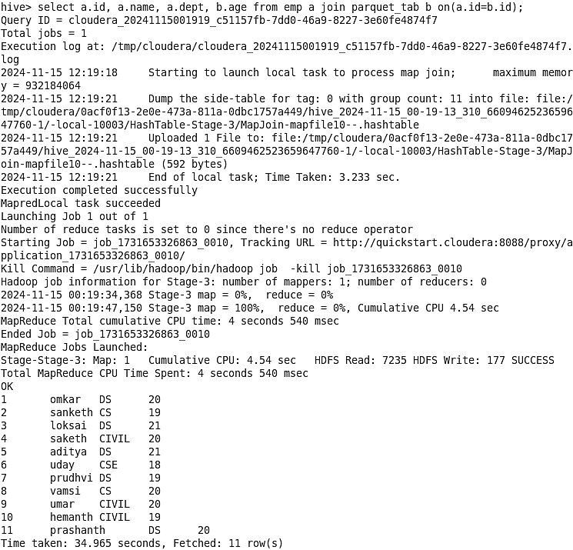



1. **Partitioning**

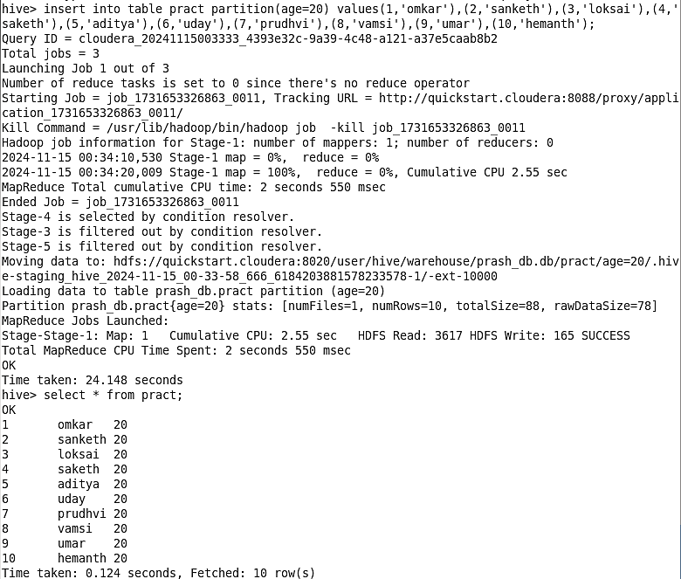



1. **Views**

**Salary <85k**

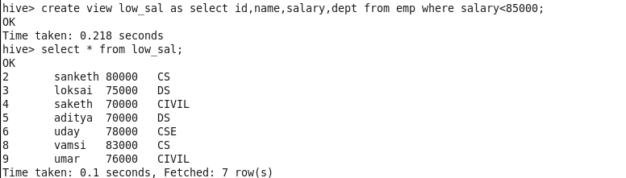

**Salary >85k**

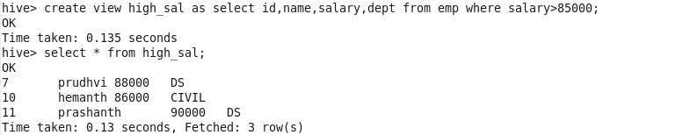

1. **Altering Table**

